Novice Team – First Routine – Page 1
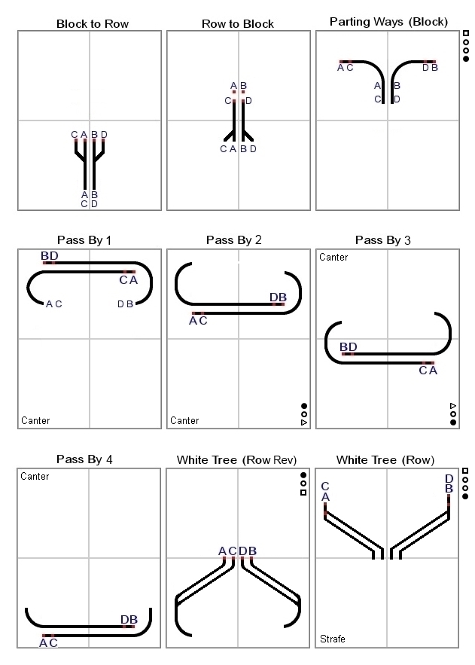
Novice Team – First Routine – Page 2
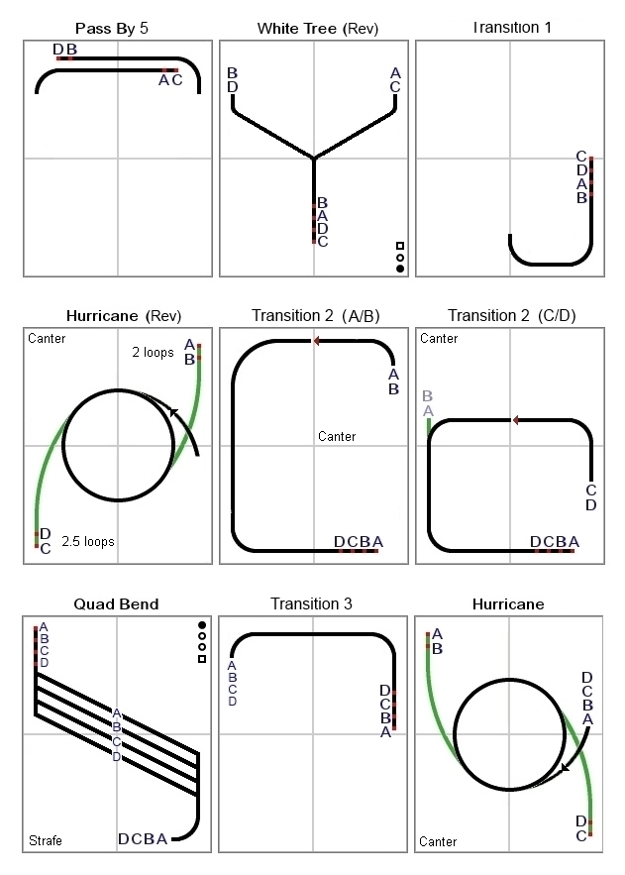
Novice Team – First Routine – Page 3
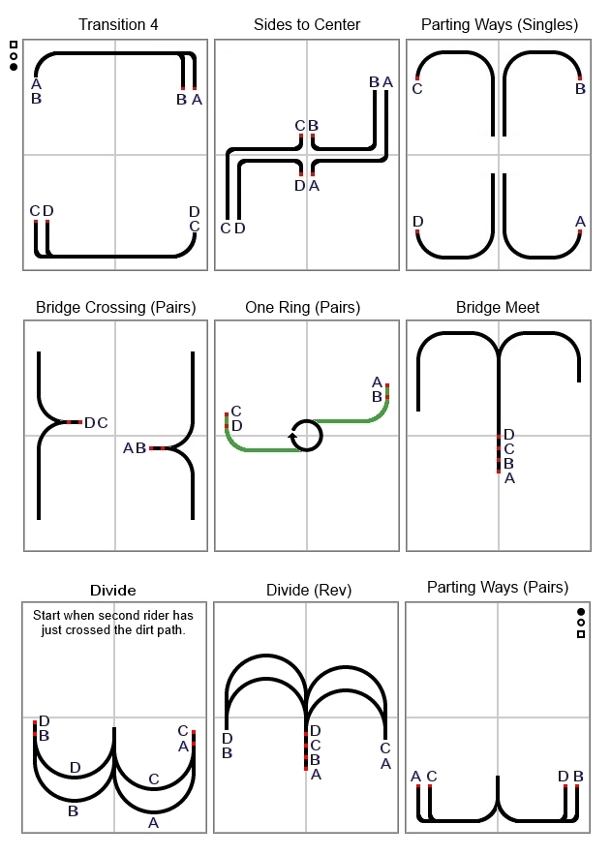
Novice Team – First Routine – Page 4
